OPG Pro Payment System: Approval Hierarchy & Workflow

1. Standard Approval Hierarchy
The system maps user roles to seven specific hierarchical levels.
Level | Role Identifier | Designation
Level 1 | hodorsbuhead | HOD or SBU Head
Level 2.1 | centralcommittee1 | Central Committee (1)
Level 2.2 | centralcommittee2 | Central Committee (2)
Level 2.3 | centralcommittee3 | Central Committee (3)
Level 3 | macs | Manager Accounts (M(A/Cs))
Level 4 | hooperations | Head Office Operations (HO-Operations)
Level 5 | Pfa | Project Finance & Accounts (P(F&A))
Level 6 | headcommercial | Head-Commercial
Level 7 | Ceo | Chief Executive Officer (CEO)

2. Amount-Based Approval Thresholds
Workflow termination is determined by the following financial limits:
- Up to ₹100,000: Levels 1 through 3
- Up to ₹500,000: Levels 1 through 5
- Up to ₹1,000,000: Levels 1 through 6
- Above ₹1,000,000: Full Levels 1 through 7

3. Department-Specific Routing Rules

3.1 Departments that Skips Level 2 (Direct to Level 3)
The following departments bypass all Level 2 (Central Committee) requirements for amounts ≤ ₹100,000. The flow proceeds directly from Level 1 → Level 3.
- CoalPurchase
- HR&Admin
- Admin-Ho
- CSR
- Finance
- Account
- Legal
- IT-HO
- Secretary
- EPC.

3.2 Level 2 Partial Skip ( Direct to Level 2.3 )
The following departments bypass Level 2.1 and 2.2. The flow proceeds as Level 1 → Level 2.3 → Level 3.
- Fleet

3.3 Sequential Approval (Full Level 2 Path)
The following departments must complete the full sequential approval chain (Level 2.1, 2.2, and 2.3):
- MMD
- EMD
- IMD
- O&E
- CHP/AHP
- WTA/LAB
- Operation
- EHS
- Admin Plant
- Civil
- Material
- IT-Plant
- Bio Energy
- Solar.

4. System Implementation Logic
The OPG Pro system executes approvals based on a three-point validation:
- Department Validation: Checks for "Skip" or "Partial Skip" rules.
- Amount Validation: Sets the "Approval Ceiling" (the final level required).
- Role Mapping: Identifies the specific authorized user for each required level.

4. Application Screenshot
Below are the application work flow screenshots and pages :
- Home Page
- Payment Voucher List
- Payment Approval Page
- Voucher Details View
- Approval Report Page

- Home Page

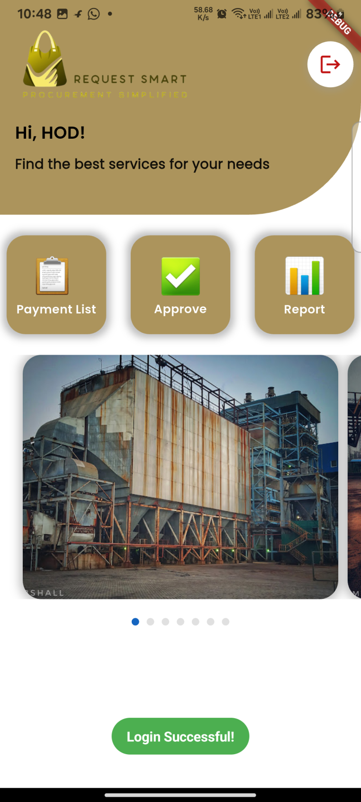

2.Payment Voucher List

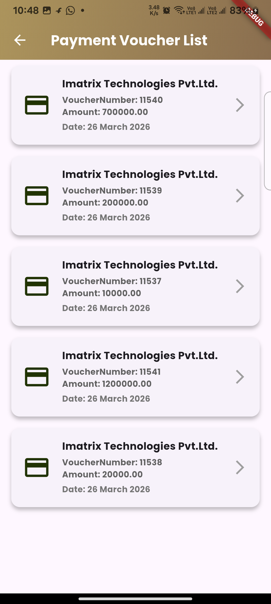

3.Payment Approval Page

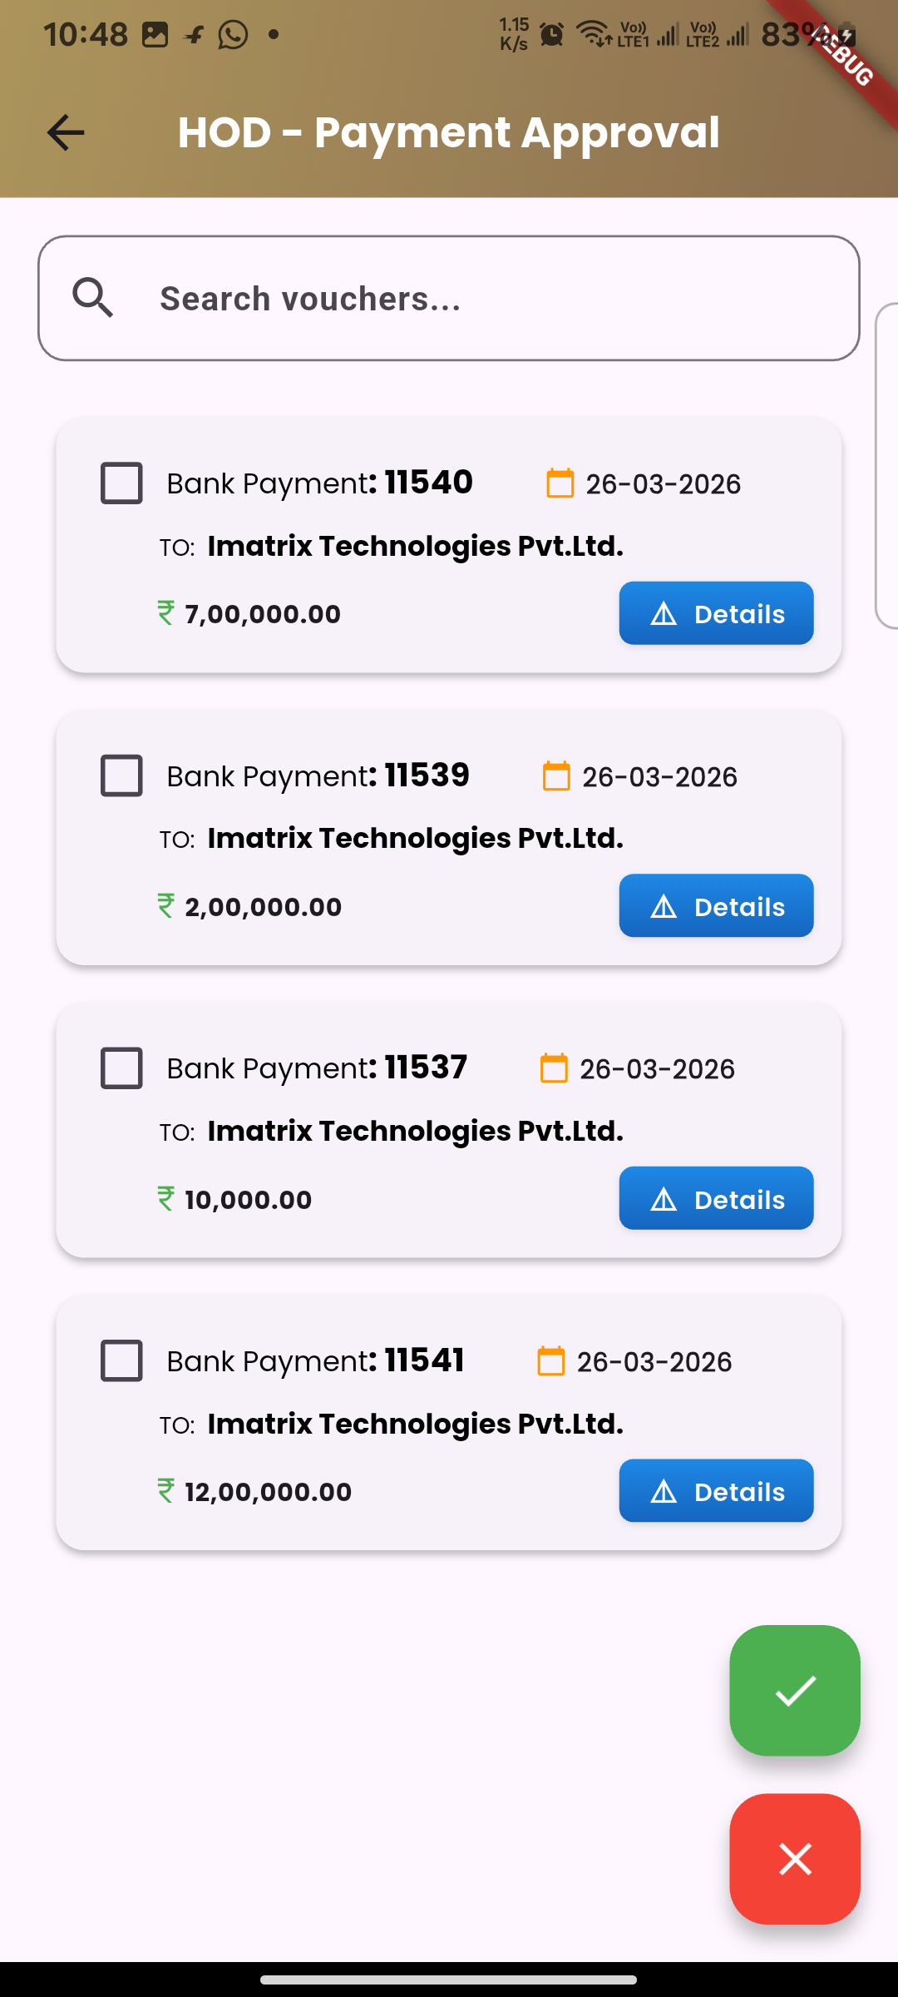

4.Voucher Details View
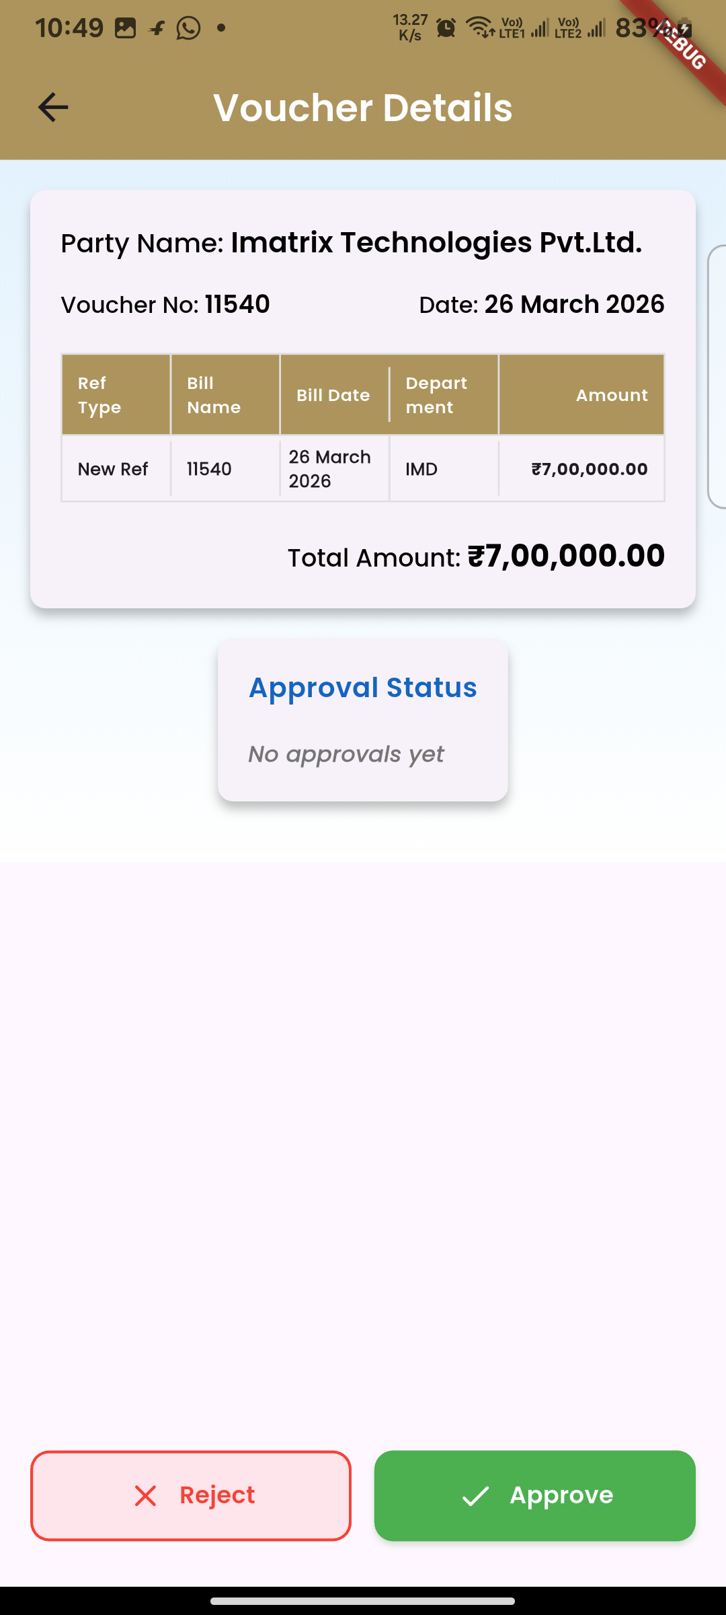

5.Approval Report Page
